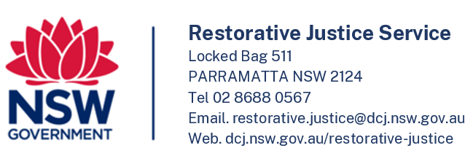

Apology Letter Bank - Enquiry

If you are a victim/survivor of crime and are interested in being informed that a person who has been sentenced for the offence has submitted a letter to the Apology Letter Bank, please complete this form and post or email it to us.

Date:

|  |  |  |  |
| --- | --- | --- | --- |
| Your Details: | | | |
| First name/s: |  | Surname: |
| Phone number: |  | | |
| E-mail address: |  | | |
| Current Address: |  | | |
|  | | | |

|  |  |  |
| --- | --- | --- |
| Are you of Aboriginal or Torres Strait Islander origin? | No  Prefer not to say | Yes, Aboriginal  Yes, Torres Strait Islander |

|  |  |  |  |  |
| --- | --- | --- | --- | --- |
| The Offence: | | | | |
| Type of offence: |  | | | |
| Offender’s first name: |  | Surname: | | |
| Offender’s MIN No. (if known): |  | Offender’s Date of Birth (if known): |  | |
| Has the offender been sentenced? | Yes  No | Is there an active AVO - Type 2? |  | Yes  No | |

|  |  |
| --- | --- |
| Arranging Contact: | |
| A Restorative Justice facilitator can contact me by: | Phone (please answer the questions below)  Email  Post |
| The best time of day to phone me: |  |
| Do not call me on these day(s): |  |
| I will need a translator to speak with you on the phone: | No  Yes, and my language is: |
| I will need assistance to speak on the phone (please give details): |  |

*If you have filled out this form on behalf of the victim/survivor, please complete the following:*

|  |  |  |  |
| --- | --- | --- | --- |
| Representative’s Details | | | |
| First name/s: |  | Surname: |
| Phone number: |  | |
| E-mail address: |  | |
| Relationship: |  | |
| Organisation: |  | |

**END OF FORM**